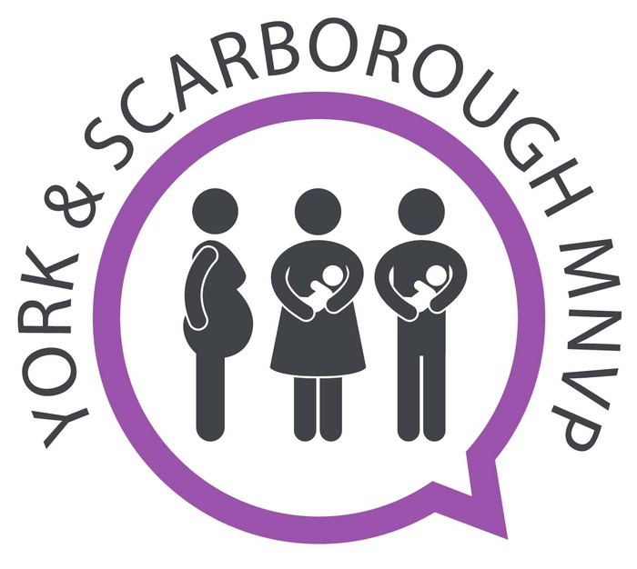

Role Description: Neonatal Lead Template

The role would suit an individual who is passionate about developing Neonatal care and engaging with families across the diverse communities of York and Scarborough. This role requires some flexibility in terms of time but we also recognise and accommodate, where possible, the other commitments you may have, including work, parenting and other caring commitments.

About the Role

We are looking for a Neonatal Lead to join the York and Scarborough Maternity and Neonatal Voices Partnership (MNVP) who:

- Is passionate about helping to develop and improve the experience of Neonatal services for women, birthing people and their families whose baby/babies require Neonatal care.
- Has lived experience of Neonatal care and services.
- Is keen to engage with families and seldom listened to groups to inform Neonatal services development.
- Is a good communicator, who will consider a range of mechanisms to communicate with service users.
- Is organised, and willing and able to work flexibly.
- Is able to attend MNVP quarterly meetings,
- Is able to host and/or attend coffee mornings and other outreach Neonatal group meetings and events. (budget support provided)

What is an MNVP?
Maternity and Neonatal Voices Partnerships hold responsibility to act as multidisciplinary working groups with the primary function of embedding the service user experience as a method for review and co-design of maternity services.

The groups are made up of a Lead, MNVP lay roles, women, birthing people and their families, healthcare professionals such as Midwives, Health visitors, GP’s, support workers, local commissioners, charities, and community groups.

Role Responsibilities

Key Responsibilities:

- Work closely with the MNVP Leads and the ODN Parent and Families Engagement Lead.
- Work with the MNVP Group Lead
- Work in collaboration with Trust Neonatal staff.
- Work in collaboration with the Yorkshire and Humber Neonatal Operational Delivery Network (ODN), as part of the Co-Production Meeting.
- Be one of the points of contact for Neonatal enquiries to the MNVP.
- Regularly share Neonatal links relevant to the MNVP.
- Help to create and circulate Neonatal surveys and gather feedback.
- Liaise with Neonatal Unit leads on a regular basis

Formal Meetings:

- Attend and provide an update to the four MNVP meetings (quarterly) per year.
- Attend regular Teams calls or face-to-face meetings with the MNVP Leads to discuss issues and updates.
- Attend and represent the MNVP at ODN Co-Production meetings.

Ensuring We Hear the Voice of Service Users and their Families:

- Organise and attend at least four community-based listening events per year across the patch.
- Input into already established community groups, ie twins/multiple clubs etc
- Build relationships within the community serving parents and families.

Workplan and Annual Report

- Work as a project lead for Neonatal and contribute to a section of the annual workplan and annual report.

Social Media

- Input as required to the MNVP social mediafeeds (Facebook, Instagram and Twitter).

Additional

- Administration, such as meeting notes, emails, invites, posters etc.
- Respond to Neonatal enquiries via email and social media.
- Actively network and engage with other MNVPs in our Local Maternity and Neonatal System and region.
- Link with the Yorkshire and Humber Neonatal ODN to ensure Neonatal parental feedback is heard at an ODN/Commissioning level.

Effective Neonatal Leads

- Have lived experience - they will be a parent whose baby/ies has/have spent time in Neonatal care and/or accessed Neonatal services, whether this is more recently or in recent years. They will be able to champion and seek out the voices of this group to support them to be listened to effectively.

- Are well prepared - begin by reading the relevant paperwork before meetings; if they have the opportunity, they can add to this by researching the issues under discussion, finding out about the provider’s performance and how it compares with other providers, exploring the latest research evidence etc.

- Work well with others - both with those who share similar interests and perspectives, and with those who hold differing views and priorities, so they show them respect and understand their perspectives.

- Understand the remit of the MNVP and their own role – familiarise themselves with the MNVP’s Terms of Reference and with the role of an MNVP.

- Be passionate about a range of Neonatal interests and contribute to a range of topics.

- Encourage and support the MNVP to function well – for example, meeting papers should be circulated well in advance and key notes and action points undertaken soon after.

- Keep up to date with national and local Neonatal issues - by accessing local, regional and national bulletins, published guidance, support documents, and workshops etc.

- Have an understanding of the structure of the NHS and Neonatal services place within it - increase their knowledge of the functioning of the NHS and neonatal services through related policy documents.

- Are confident, assertive, compassionate and resilient - everyone is equal in an MNVP. Their views and those of Service Users are valuable.

- Able to provide time each month - for the tasks listed above, including face-to-face contact, attending informal and formal meetings, undertaking engagement and collating feedback and papers.

- Are remunerated for their time and reasonable expenses - as agreed with the MNVP Leads.

- Ensure they maintain confidentiality of the issues and personal data they discuss. Be aware of and abide by the MNVP Privacy_Policy.

- Act in accordance with the Nolan_Principles_of_Conduct_in_Public_Life, when carrying out this role – selflessness, integrity, objectivity, accountability, openness, honesty and leadership.

Commitment and Remuneration

Renumeration and Time
The MNVP Roles are renumerated at £150 per day (7.5 hours) and does include expenses for travel, remote meetings, childcare and refreshments.
The Neonatal Engagement Lead is based on two days per month and will initially be for 6 months when the role will be reviewed.
Due to the nature of the role, the ideal candidate will be required to work flexibly around meetings and may choose to split this into half days or hours. The candidate will be required to log their hours and they will be responsible for managing their own time and monthly catch up's with the MNVP Lead. The Lead will help to prioritise your time and requirements.

It’s important to note that this is an independent role classified as an IR35 off pay role position which means, you will be required to invoice the LMNS each month with your hours and expenses. The reason for this is to ensure that the MNVP has an impartial voice and that they can be a critical friend in improving our neonatal services. It also ensures a safe mechanism for our service users to provide feedback that will be anonymised, so they won't have a fear of any repercussions for providing their own experiences, thoughts and feelings.

The role is home based with travel across the area.

Training and Support
Your main line of support will be from the MNVP Lead who will help you to settle into the role and the ODN Parent and Families Engagement Lead.
There is also a number of people who you can call upon for support such as liaising closely with Trust staff, the LMNS Group lead and the MNVP network (based on WhatsApp, Facebook, and NHS Futures)
There will also be training opportunities and IT equipment can be provided if needed.

How to apply:
For an informal chat please contact Helen McConnell helen.mcconnell3@nhs.net
To apply for the role please complete the expression of interest form by 7th May 2024
and send to Heidi Forster heidi.forster2@nhs.net, if you haven’t received an acknowledgement of receipt within 48 hours please re-send it to ensure receipt.

